Database Administration
Ryan Coon
SSD-620
Dr. Benjamin Perez
September 16, 2026

Part 1
In a company’s database management ecosystem, the roles of the production DBA (Database Administrator) and the developer DBA are distinct yet complementary, each focusing on separate priorities that collectively support application development and data integrity. The production DBA primarily ensures the stability, security, and performance of the live database environment, while the developer DBA focuses on designing the database schema, enforcing data standards, and supporting application development.
The production DBA is responsible for maintaining the operational health of the database systems that support business-critical applications. This role involves monitoring database performance, tuning queries, managing backups and recovery, and ensuring high availability and security of production data. In contrast, the developer DBA collaborates closely with application developers to design efficient database schemas, enforce data standards, and implement business rules within the database. This DBA role is crucial in shaping how data is structured and accessed, ensuring that the database supports application requirements effectively.
One of the key responsibilities of the developer DBA is to design and enforce data standards that promote data quality, consistency, and integrity. For an online video store, three important data standards might include: (1) enforcing consistent naming conventions for tables and columns to improve readability and maintainability (2) implementing data validation rules to ensure that fields such as video titles, release dates, and customer information adhere to expected formats and constraints and (3) establishing referential integrity through foreign key constraints to maintain valid relationships between entities like customers, rentals, and videos. These standards help maintain the ACID properties of the database atomicity, consistency, isolation, and durability by ensuring that transactions are processed reliably and data remains accurate and consistent even in the event of failures or concurrent access.
Regarding database security, the production DBA typically determines user access and privileges, as this role oversees the live environment where data sensitivity and regulatory compliance are paramount. The production DBA implements role-based access controls, audits user activities, and enforces strict security policies to protect production data from unauthorized access. Meanwhile, the developer DBA approaches security from a development perspective, ensuring that security considerations are integrated into database design and that developers follow secure coding practices. This includes managing access to development and test environments, which often have different security requirements than production.
User training and management usually fall under the production DBA’s responsibilities, as this role interacts with end-users, application teams, and support staff to ensure proper use of the database systems. The production DBA organizes training sessions, develops user documentation, and manages user accounts and permissions to maintain operational security and efficiency.
Performance monitoring and tuning are critical tasks for the production DBA. Tools such as Oracle Enterprise Manager, SQL Server Management Studio, or open-source options like pgAdmin provide dashboards and alerts for monitoring CPU usage, memory consumption, query execution times, and disk I/O. Key metrics include query response time, transaction throughput, lock contention, and cache hit ratios. By analyzing these metrics, the production DBA can identify bottlenecks, optimize indexes, and adjust configurations to enhance database performance.
Both the production and developer DBAs collaborate to develop operating procedures for backups, recovery, and transaction logging. The production DBA focuses on implementing robust backup schedules, disaster recovery plans, and ensuring transaction logs are properly maintained to enable point-in-time recovery. The developer DBA contributes by designing database schemas and transactions that facilitate efficient logging and recovery, such as using appropriate isolation levels and minimizing long-running transactions that can complicate recovery.
To support development and testing, the production DBA secures production data by creating sanitized copies of the production database. This involves masking or anonymizing sensitive information to protect customer privacy while providing realistic datasets for developers and testers. This practice ensures that development teams have access to accurate data without compromising security or compliance.
In summary, the production DBA and developer DBA have distinct but interrelated roles that together ensure the database environment is secure, performant, and aligned with application needs. The production DBA prioritizes operational stability, security, and user management, while the developer DBA focuses on schema design, data standards, and supporting application development. Their collaboration is essential for maintaining the integrity and availability of the database throughout its lifecycle.

Part 2
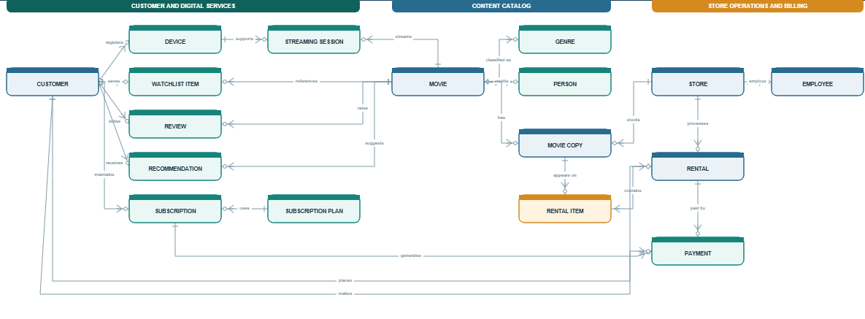

New capabilities represented
New entity/tool | Requirement supported
STREAMING_SESSION | Records when a customer streams a movie, the device used, start/end times, and playback progress.
SUBSCRIPTION and SUBSCRIPTION_PLAN | Supports recurring membership tiers, prices, billing cycles, and subscription status.
PAYMENT | Records rental and subscription charges, payment method, amount, date, and payment status.
REVIEW | Stores customer ratings and written reviews for movies.
WATCHLIST_ITEM | Lets customers save movies for later viewing.
RECOMMENDATION | Stores personalized movie suggestions and the reason or score behind them.
DEVICE | Tracks devices authorized to access the streaming service.
GENRE | Supports searchable movie categories and allows a movie to belong to multiple genres.
PERSON | Represents actors, directors, and other credited people without duplicating their information.
Business rules
- A customer may place many rentals, but each rental belongs to one customer.
- A rental contains one or more rental items; each rental item refers to one physical movie copy.
- A movie may have many physical copies, and each copy is stocked by one store.
- A customer may maintain subscriptions, and each subscription uses one subscription plan.
- A customer may stream many movies on registered devices; every streaming session identifies one customer, one movie, and one device.
- Payments may settle a rental or a subscription charge.
- Customers may review movies, save movies to watchlists, and receive movie recommendations.
- Movies may belong to multiple genres and may credit multiple people; genres and people may relate to many movies.

References
IBM. (2026). Database Administration Best Practices. Retrieved from https://www.ibm.com/docs/en/db2/
Microsoft. (2024). SQL Server Database Administrator Guide. Retrieved from https://docs.microsoft.com/en-us/sql/
Oracle. (2025). Database Administrator Roles and Responsibilities. Retrieved from https://docs.oracle.com/en/database/
Yugabyte. (2025). Database Scalability and Administration. Retrieved from https://www.yugabyte.com/key-concepts/what-is-database-scalability/

